National Textile University, Faisalabad

Department of Computer Science
Name | Dawood Saif  Ahmad Fawad
Class | SE-5th (A)
Reg. No. | 23-NTU-CS-1145  23-NTU-CS-1129
Course | Operating System
Submitted To | Dr. Nasir Mehmood
Submission Date | 05/01/2026
Documentation | OS Project Documentation on Docker

Operating System
Web Application Project Containerized Using Docker
Project Name: E-commerce Website (Watch Hub)

Introduction
Docker is an open-source platform used to build, ship, and run applications inside lightweight containers. Docker allows applications and their dependencies to be packaged together, ensuring consistency across different environments. In the Watch Hub Online Watch Store project, Docker is used to containerize the full-stack web application consisting of a frontend, backend API, and database.
By using Docker, the Watch Hub system can run consistently on any machine without environment-specific issues. Docker eliminates the common problem of “it works on my machine” by ensuring that the application behaves the same in development, testing, and production environments. Each service runs in its own isolated container, improving reliability and maintainability.

Benefits of Dockerization
- Consistency: Docker containers package the application along with all required dependencies. This ensures that Watch Hub runs the same way across all platforms, including Windows, macOS, Linux, and cloud servers.
- Isolation: Each component of the Watch Hub system (frontend, backend, database) runs in a separate container. This isolation prevents conflicts between libraries, frameworks, or runtime versions and improves system stability.
- Portability: Dockerized applications can be easily moved between environments. The Watch Hub containers can be deployed on local machines, university servers, or cloud platforms without additional configuration.
- Scalability: Docker containers are lightweight and can be scaled horizontally. Multiple instances of the Watch Hub backend or frontend can be launched to handle increased traffic.
- Simplified Deployment: Using Docker Compose, the entire Watch Hub application stack can be started with a single command. This simplifies deployment and reduces manual configuration. Application stack with minimal manual steps, as opposed to configuring each service separately.
Dockerization Process
- Frontend Docker file: A multi-stage Docker file was created for the Next.js frontend to optimize size and performance. The first (builder) stage uses a Node.js 18 base image to install dependencies and run next build, generating the production output. The second (runtime) stage starts from a clean Node.js Alpine image, then copies only the built output into it. Specifically, it copies the .next/standalone folder, the .next/static files, and the public directory into the final imagedev.to. This approach leverages Next.js built-in output: 'standalone' modenextjs.org. By enabling output: 'standalone' in next.config.ts, Next.js produces a minimal set of files needed for the production servernextjs.org. In practice, this means the final Docker image contains only the runnable application files – no dev tools or unnecessary source code. Following Docker’s best practices, we run the app with a non-root user in a small Alpine-based containerdev.todocs.docker.com. Using this multi-stage + standalone strategy dramatically shrinks the image size (one case study reports a ~90% reduction)dev.to.
- Backend Dockerfile: The Node.js/Express server also has its own Dockerfile. This uses a Node 18 (Alpine) base image, copies the server code, and installs dependencies (e.g. via npm install or yarn install). Similar to the frontend, we apply multi-stage principles: we can install all dependencies in an intermediate stage and then copy only the necessary runtime files into a clean final image. We also create and switch to a non-root node user in the final stage for security. As Docker’s Node.js guide recommends, this yields a lean, production-ready image with only the runtime dependencies and the server codedocs.docker.com.
- Docker Compose: A docker-compose.yml file was created to orchestrate all three services (frontend, server, and mongo). In Compose, each service is defined in one file, including how to build or pull its image, which ports to expose, and what environment variables to setmedium.com. For example, the frontend service uses the Next.js Dockerfile, the server uses the Node Dockerfile, and the mongo service pulls the official MongoDB image. Running docker-compose up --build then builds (or pulls) the images and starts all containers in one gomedium.com. Compose also sets up a default network for the appdocs.docker.com. In this network, each service can be reached by its service name. For instance, the backend server can connect to MongoDB at the hostname mongo:27017 because we named the database service mongodocs.docker.comdocs.docker.com. In summary, Docker Compose automatically handles networking, volume management, and environment interpolation, so the entire stack comes up in a coordinated way.
- Configuration: We updated the Next.js configuration (next.config.ts) to ensure compatibility with Docker. In particular, we set output: 'standalone'nextjs.org so that Next.js emits the minimal server build. This avoids the older (now-deprecated) serverless target and ensures the Docker image only includes the essential filesnextjs.org. Any needed environment variables (like API endpoints or database URIs) are also configured, typically via .env files or in the Compose file, so that the containers can connect to each other and external services correctly.
How to Run
- Prerequisites: Install Docker and Docker Compose on your machine. For example, Docker Desktop (for Windows/macOS) or Docker Engine (on Linux)docs.docker.com. Ensure the docker and docker-compose commands are available in your PATH.
- Start the application: In the project’s root directory, run:
- docker-compose up –build: The --build flag forces a rebuild of images if there are changes. This command will automatically pull/build all images and start the three services. Docker Compose will create a network and launch the frontend, server, and mongo containers, wiring them together as definedmedium.com.
- Access the application:
Frontend: Open your browser to http://localhost:3000. This is where the Next.js UI is served.
Backend API: The Node/Express API is reachable at http://localhost:5000.
Database: MongoDB is running internally on port 27017. You can connect to it with a Mongo client using the connection string mongodb://localhost:27017, assuming you mapped that port in Compose.
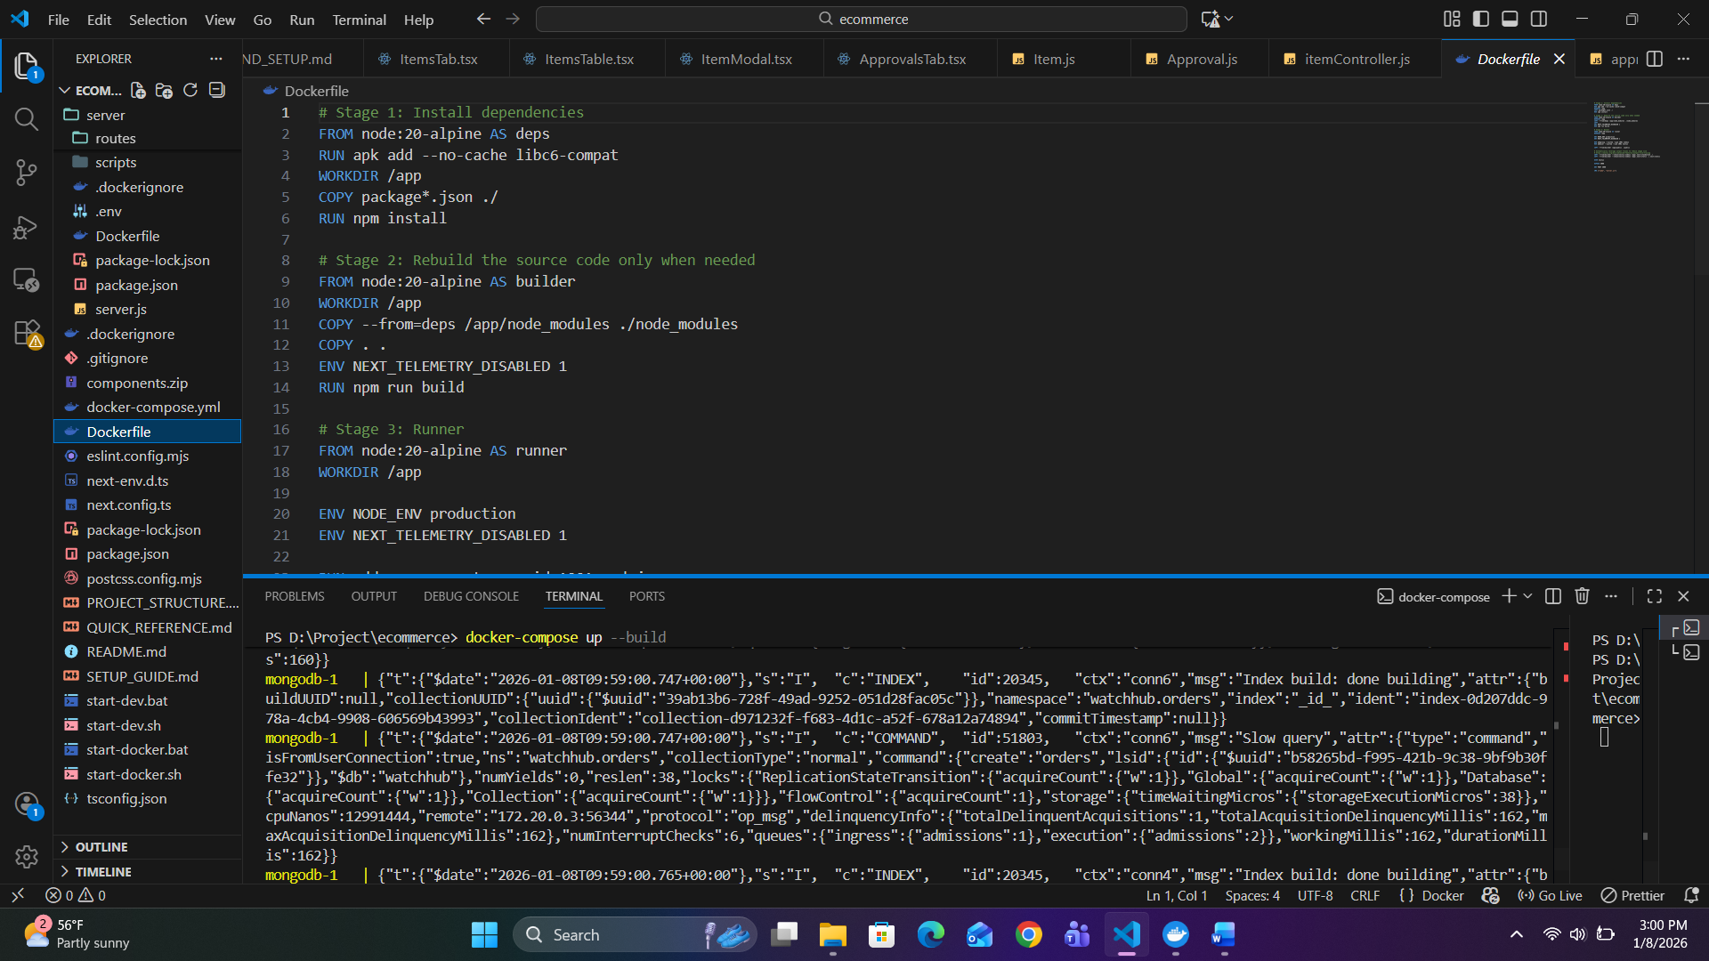

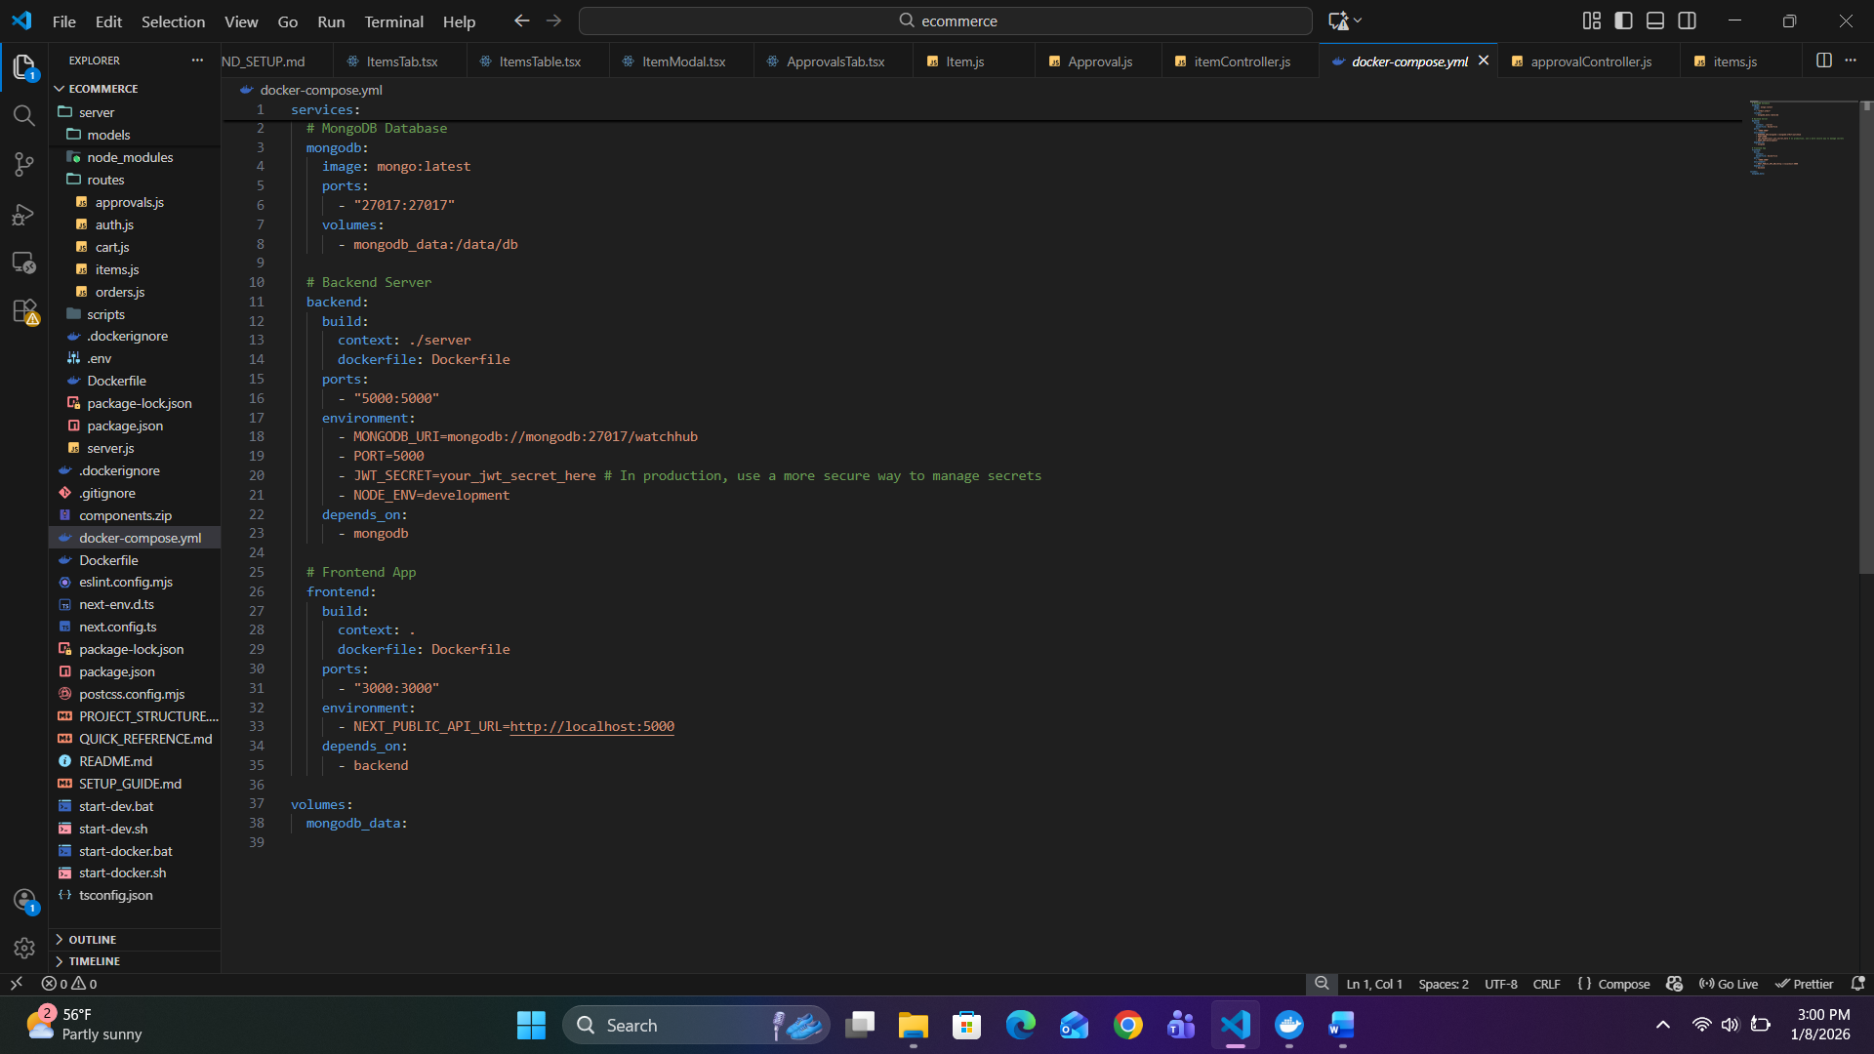

Troubleshooting
- Port Conflicts: If your host already has services on ports 3000, 5000, or 27017, you will see errors when starting Compose. Stop the conflicting services or change the port mappings in docker-compose.yml (the HOST:CONTAINER port syntax). For example, you could map the frontend to - "3001:3000" to use port 3001 instead. Note that Docker distinguishes between the host and container ports, so changing the host side is how you avoid conflictsdocs.docker.com.
- Database Connection: By default, Docker Compose sets up a single network where each container can reach the others by the service name. Ensure your application’s MONGODB_URI (or similar) uses the MongoDB service name (mongo) as the hostname. For example, use mongodb://mongo:27017/fvs. In Compose, the service name “mongo” resolves to the MongoDB container’s IPdocs.docker.comdocs.docker.com. If you misname the service or use localhost, the containers won’t connect to each other as intended.

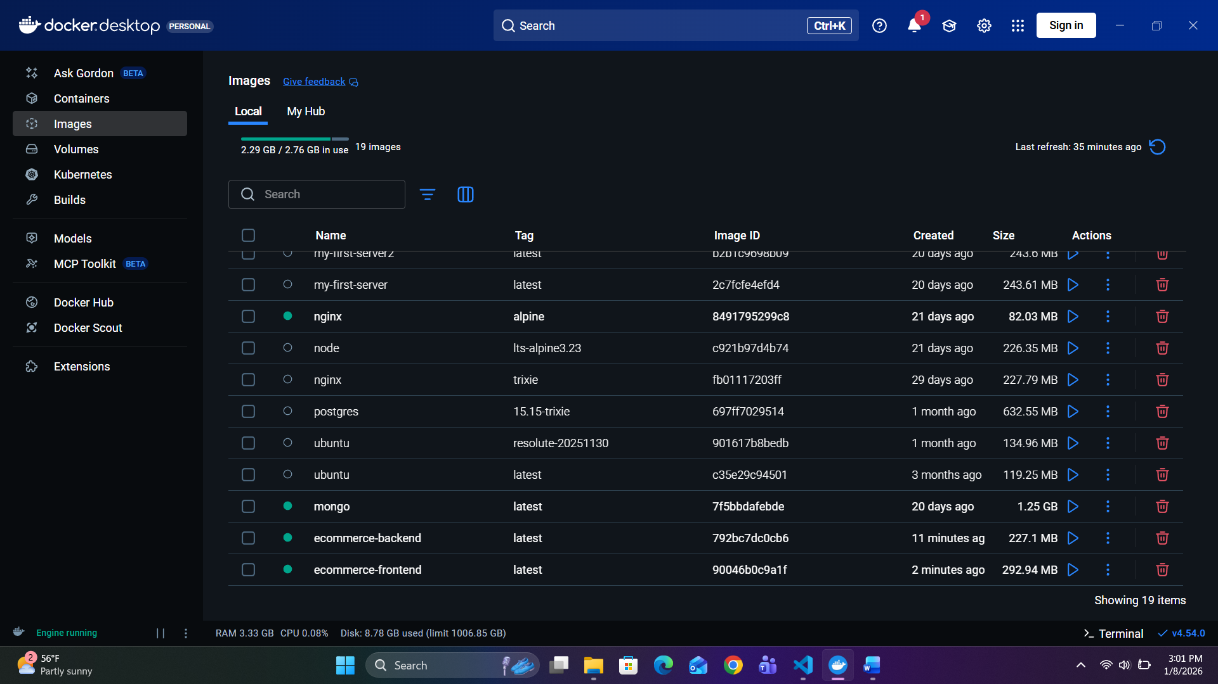

Sources:
This documentation is based on Docker’s official guides and best practicesdocs.docker.commedium.com, the Next.js documentation on production buildsnextjs.org, and community resources on optimizing Docker imagesdev.tocycle.iodocs.docker.com. These sources describe how containerization provides consistency, isolation, portability, and simplified deployment, as well as how to structure multi-stage Docker files and use Docker Compose effectively.

